Problems with OLS in Panel Data, because there is a co-relation error. Likely the data has a relationship )e.g population of NY over time vs Chicago) and also there will be a relationship with the error terms, which is an issue for OLS.

I = cross section

T = time series

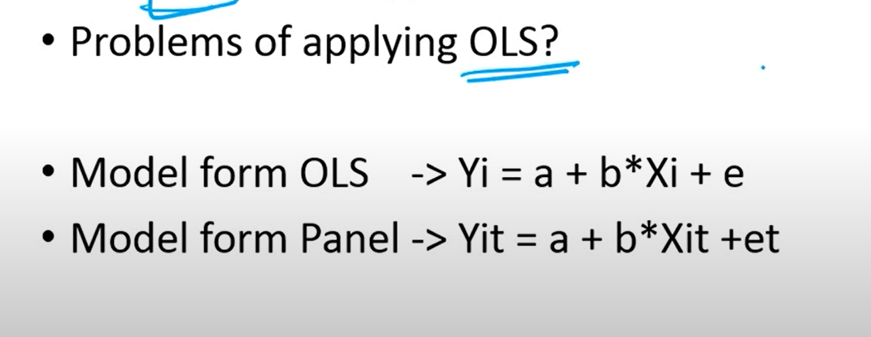

How I need to strucute my data:

Emp ID = country

Time = year

Columns d-f are independent variables (so

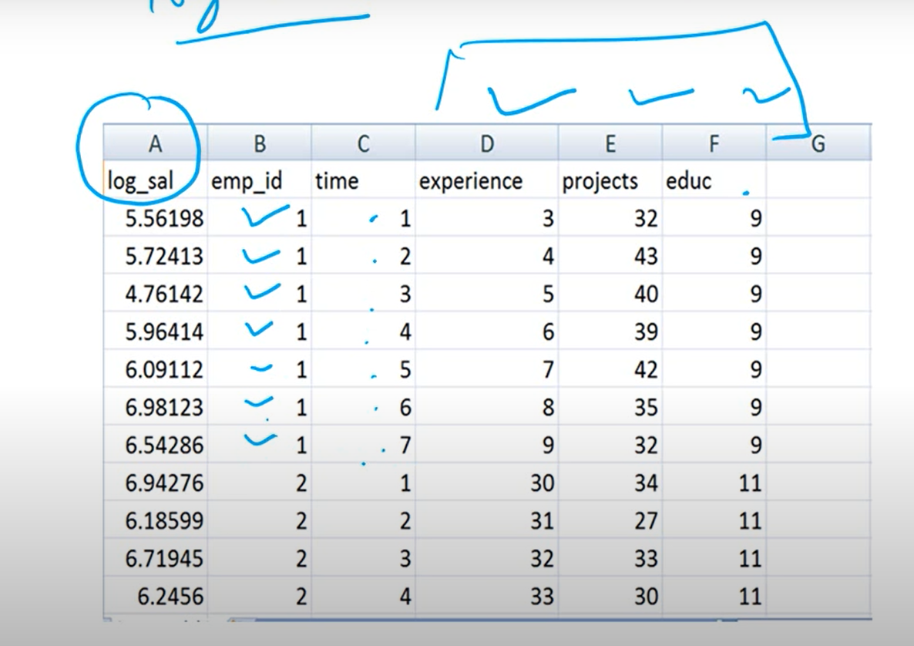

Pooled OLS Regression: He doesn this to show WEAKNESS of method for panel data

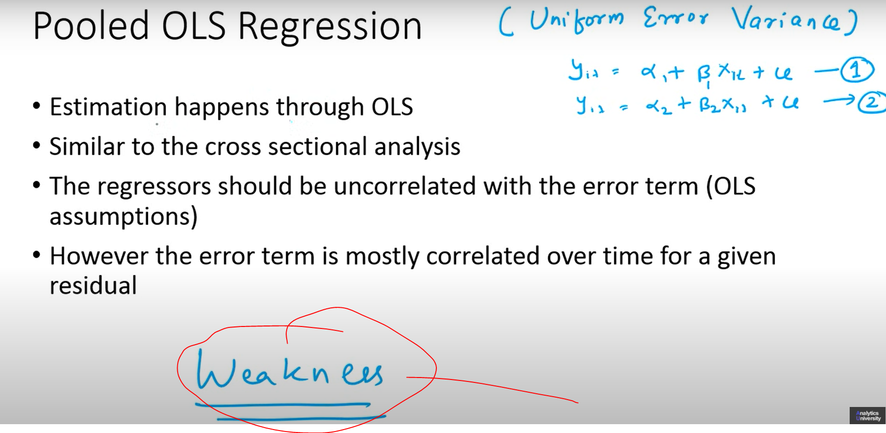

R-Code: 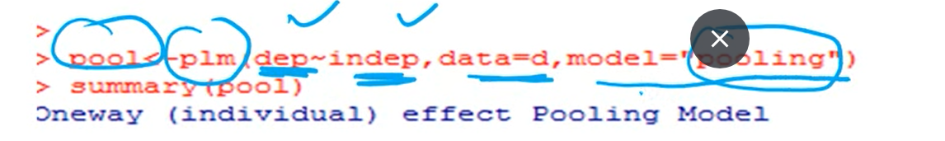

Youtube: 21min

Panel Data: Descriptive Analysis

